Tuabin gió: thân thiện với môi trường

Gió là một dạng của năng lượng mặt trời. Gió được sinh ra là do nguyên nhân mặt trời đốt nóng khí quyển, do trái đất xoay quanh mặt trời và do sự không đồng đều trên bề mặt trái đất. Luồng gió thay đổi tuỳ thuộc vào địa hình trái đất, luồng nước, cây cối, con người sử dụng luồng gió hoặc sự chuyển động năng lượng cho nhiều mục đích như: đi thuyền, thả diều và phát điện.
Năng lượng gió được mô tả như một quá trình, nó được sử dụng để phát ra năng lượng cơ hoặc điện. Tuabin gió sẽ chuyển đổi từ động lực của gió thành năng lượng cơ. Năng lượng cơ này có thể sử dụng cho những công việc cụ thể như là bơm nước hoặc các máy nghiền lương thực hoặc cho một máy phát có thể chuyển đổi từ năng lượng cơ thành năng lượng điện.
Để hiểu rõ hơn Cục Thông tin KH&CN quốc gia xin giới thiệu một số bài nghiên cứu đã được xuất bản chính thức và các bài viết được chấp nhận đăng trên những cơ sở dữ liệu học thuật chính thống.
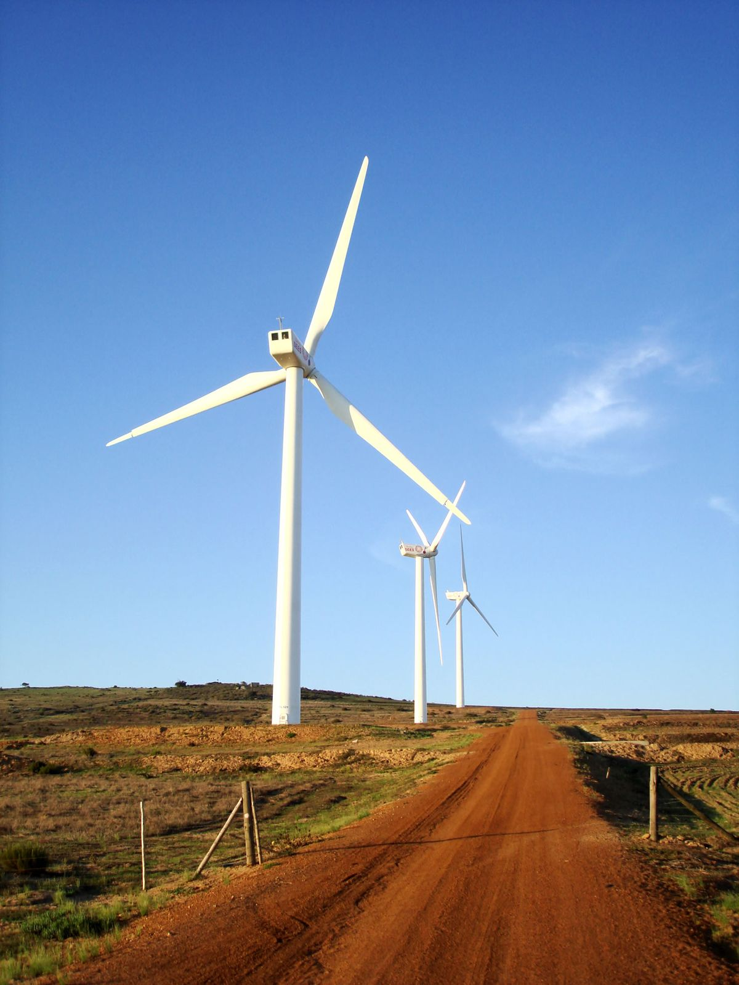

1. Sciencedirect
1. Acoustic noise emission of air turbines for wave energy conversion: Assessment and analysis
Renewable Energy22 May 2023Volume 212 (Cover date: August 2023)Pages 897-907
J. C. C. HenriquesL. M. C. GatoA. A. D. Carrelhas
https://www.sciencedirect.com/science/article/pii/S0960148123007012/pdfft?md5=85156defbcc06c0d0f38a5e682d711c3&pid=1-s2.0-S0960148123007012-main.pdf
2. A comparative examination of the aerodynamic performance of various seashell-shaped wind turbines
Heliyon7 June 2023Volume 9, Issue 6 (Cover date: June 2023)Article e17036
Hossam HamidRafea Mohamed Abd El Maksoud
https://www.sciencedirect.com/science/article/pii/S2405844023042445/pdfft?md5=b9d75c72443404604e26857e52e1975b&pid=1-s2.0-S2405844023042445-main.pdf
3. A hybrid method for modelling wake flow of a wind turbine
Ocean Engineering17 May 2023Volume 281 (Cover date: 1 August 2023)Article 114770
Yuming YuanQ. W. MaAbbas Khayyer
https://www.sciencedirect.com/science/article/pii/S002980182301154X/pdfft?md5=bf21526ccb5a0e1d305562de550430c2&pid=1-s2.0-S002980182301154X-main.pdf
4. Dual steam turbines in biogas power processes
Chemical Engineering and Processing - Process Intensification6 May 2023Volume 190 (Cover date: August 2023)Article 109412
William L. Luyben
https://www.sciencedirect.com/science/article/pii/S0255270123001496/pdfft?md5=06d4bce9bee02d03a375281b61167524&pid=1-s2.0-S0255270123001496-main.pdf
5. Efficiency optimization of twin vertical-axis helical hydrokinetic turbines (VAHHTs) based on Taguchi method
Applied Ocean Research9 June 2023Volume 138 (Cover date: September 2023)Article 103618
Dan ChenYong MaTiancong Zhao
https://www.sciencedirect.com/science/article/pii/S0141118723001591/pdfft?md5=22d87a13046f5ca5679732e64df7afe7&pid=1-s2.0-S0141118723001591-main.pdf
6. Biplane-rotor Wells turbine: The influence of solidity, presence of guide vanes and comparison with other configurations
Energy17 April 2023Volume 276 (Cover date: 1 August 2023)Article 127514
F. J. F. MoraisA. A. D. CarrelhasL. M. C. Gato
https://www.sciencedirect.com/science/article/pii/S0360544223009088/pdfft?md5=73feaceefc197c45eedd293ec497e9f4&pid=1-s2.0-S0360544223009088-main.pdf
7. Performance estimation of multi-stage cooled axial flow turbines under choked conditions
Applied Thermal Engineering27 May 2023Volume 230, Part B (Cover date: 25 July 2023)Article 120828
Ali Akbar ShahbaziVahid EsfahanianSaadat Zirak
https://www.sciencedirect.com/science/article/pii/S1359431123008578/pdfft?md5=bd8871092575b576490d470412a255b6&pid=1-s2.0-S1359431123008578-main.pdf
8. Numerical and experimental analyses of the performance of a vertical axis turbine with controllable-blades for ocean current energy
Energy Conversion and Management8 April 2023Volume 285 (Cover date: 1 June 2023)Article 117009
Min-Hsiung YangZhong-Ting GuRong-Hua Yeh
https://www.sciencedirect.com/science/article/pii/S0196890423003552/pdfft?md5=455e68b01f0ae58f9b3e6cef3f6a6c29&pid=1-s2.0-S0196890423003552-main.pdf
9. Research of the array spacing effect on wake interaction of tidal stream turbines
Ocean Engineering20 March 2023Volume 276 (Cover date: 15 May 2023)Article 114227
Yuquan ZhangZhi ZhangEmmanuel Fernandez-Rodriguez
https://www.sciencedirect.com/science/article/pii/S002980182300611X/pdfft?md5=ec0e2cd3507b11cb063b86c13257e06b&pid=1-s2.0-S002980182300611X-main.pdf
10. The investigation of a coaxial twin-counter-rotating turbine with variable-pitch adaptive blades
Energy24 December 2022Volume 267 (Cover date: 15 March 2023)Article 126546
Baigong WuMingjing ZhanXiao Zhang
https://www.sciencedirect.com/science/article/pii/S0360544222034338/pdfft?md5=e47820709fd8a1b76248d501cb6da346&pid=1-s2.0-S0360544222034338-main.pdf
11. Effect of leading-edge tubercles on the hydrodynamic characteristics and wake development of tidal turbines
Journal of Fluids and Structures4 April 2023Volume 119 (Cover date: May 2023)Article 103873
Menghao FanZhaocheng SunYiqi Bai
https://www.sciencedirect.com/science/article/pii/S0889974623000415/pdfft?md5=0f19d9df54e2d3688d04d23eea4347b2&pid=1-s2.0-S0889974623000415-main.pdf
12. Performance optimization of a modified Wells turbine for wave energy conversion
Ocean Engineering29 May 2023Volume 280 (Cover date: 15 July 2023)Article 114849
Ahmed T. M. KotbMohamed A. A. NawarMohamed H. Mohamed
https://www.sciencedirect.com/science/article/pii/S0029801823012337/pdfft?md5=678e514dea59ab92ddefd3a0c39cd6b2&pid=1-s2.0-S0029801823012337-main.pdf
13. Towards development and optimization of the Savonius wind turbine incorporated with a wind-lens
Energy24 March 2023Volume 274 (Cover date: 1 July 2023)Article 127263
Ali HesamiAmir H. Nikseresht
https://www.sciencedirect.com/science/article/pii/S0360544223006576/pdfft?md5=2f01051eb8e4bdb94ab033391528a154&pid=1-s2.0-S0360544223006576-main.pdf
14. Effects of detonation initial conditions on performance of pulse detonation chamber-axial turbine combined system
Energy22 May 2023Volume 278, Part A (Cover date: 1 September 2023)Article 127765
Junyu LiuZhiwu WangJingjing Huang
https://www.sciencedirect.com/science/article/pii/S0360544223011593/pdfft?md5=3b61027b1efdf34f4f33ad54b857f436&pid=1-s2.0-S0360544223011593-main.pdf
15. Hydraulic performances of a bulb turbine with full field reservoir model based on entropy production analysis
Renewable Energy28 April 2023Volume 211 (Cover date: July 2023)Pages 347-360
Soo-Hwang AhnHong TianYunpeng Yu
https://www.sciencedirect.com/science/article/pii/S0960148123006055/pdfft?md5=60aca93a7a4d09d48e9de95141f921ad&pid=1-s2.0-S0960148123006055-main.pdf
16. Numerical analysis of H-Darrieus vertical axis wind turbines with varying aspect ratios for exhaust energy extractions
Energy4 May 2023Volume 277 (Cover date: 15 August 2023)Article 127739
Enderaaj SinghSukanta RoyMing Chiat Law
https://www.sciencedirect.com/science/article/pii/S0360544223011337/pdfft?md5=24e9bf6cdb2a1bbf27b0a4ec612b1869&pid=1-s2.0-S0360544223011337-main.pdf
17. Thermodynamic performance of a radial-inflow turbine for ocean thermal energy conversion using ammonia
Renewable Energy6 December 2022Volume 202 (Cover date: January 2023)Pages 907-920
Chengbin ZhangZhe WuYongping Chen
https://www.sciencedirect.com/science/article/pii/S0960148122018092/pdfft?md5=a5dc0e68d750f9f4f7feb19107653767&pid=1-s2.0-S0960148122018092-main.pdf
18. Aerodynamic characteristics of NACA 0012 vs. NACA 4418 airfoil for wind turbine applications through CFD simulation
Materials Today: ProceedingsAvailable online 29 May 2023In press, corrected proof
Arunabha MahatoRavi Kant SinghSubhas Chandra Rana
https://www.sciencedirect.com/science/article/pii/S2214785323030754/pdfft?md5=a295c3b92d092fe529adea2df3f048b0&pid=1-s2.0-S2214785323030754-main.pdf
19. Wind turbine power and land cover effects on cumulative bat deaths
Science of The Total EnvironmentAvailable online 1 June 2023In press, journal pre-proofArticle 164536
Aristides MoustakasPanagiotis GeorgiakakisEleftherios Kapsalis
https://www.sciencedirect.com/science/article/pii/S0048969723031571/pdfft?md5=355ca525ec6e47bd86e559e4e5eeab05&pid=1-s2.0-S0048969723031571-main.pdf
20. Performance evaluation of the savonius hydrokinetic turbine using soft computing techniques
Renewable EnergyAvailable online 9 June 2023In press, journal pre-proofArticle 118906
Mohammad Sadegh KhaniYounes ShahsavaniOzgur Kisi
https://www.sciencedirect.com/science/article/pii/S0960148123008030/pdfft?md5=4d78c479e1ebfc400520209419a53202&pid=1-s2.0-S0960148123008030-main.pdf
21. Robust scheduling of remanufacturing processes for the repair of turbine blades
CIRP AnnalsAvailable online 7 June 2023In press, corrected proof
Lei LiuMarcello Urgo
https://www.sciencedirect.com/science/article/pii/S000785062300032X/pdfft?md5=3bd5fa2a76cccba9b26c1c128acfce44&pid=1-s2.0-S000785062300032X-main.pdf
22. Numerical study of aerodynamic performance of horizontal axis dual-rotor wind turbine under atmospheric boundary layers
Ocean Engineering6 June 2023Volume 280 (Cover date: 15 July 2023)Article 114944
Heming BaiNina WangDecheng Wan
https://www.sciencedirect.com/science/article/pii/S0029801823013288/pdfft?md5=330ed36d1e450916bdabbf0078485fe8&pid=1-s2.0-S0029801823013288-main.pdf
23. Performance assessment for a novel supersonic turbine engine with variable geometry and fuel precooled: From feasibility, exergy, thermoeconomic perspectives
Applied Thermal Engineering16 February 2023Volume 225 (Cover date: 5 May 2023)Article 120227
Changpeng CaiQiangang ZhengHaibo Zhang
https://www.sciencedirect.com/science/article/pii/S1359431123002569/pdfft?md5=ccd0b13becf2cba73e277f50a7c69d6f&pid=1-s2.0-S1359431123002569-main.pdf
24. Improving the efficiency of Darrieus turbines through a gear-like turbine layout
Energy28 December 2022Volume 267 (Cover date: 15 March 2023)Article 126580
Wenlong TianXiwen NiZhaoyong Mao
https://www.sciencedirect.com/science/article/pii/S0360544222034673/pdfft?md5=ea4837ed9700cea838312fc72ade7c48&pid=1-s2.0-S0360544222034673-main.pdf
25. Blade element momentum theory for a skewed coaxial turbine
Ocean Engineering3 January 2023Volume 269 (Cover date: 1 February 2023)Article 113555
Kelsey ElferingRodney MetoyerKenneth Granlund
https://www.sciencedirect.com/science/article/pii/S0029801822028384/pdfft?md5=cdff37a6845f4224afc7a7d7b9f58857&pid=1-s2.0-S0029801822028384-main.pdf
26. Study on the acoustic characteristics of a heavy-duty gas turbine combustor
Journal of Engineering Research11 April 2023Volume 11, Issue 2 (Cover date: June 2023)Article 100068
Xiaofeng LiJunfeng XiaoJiaxing Xia
https://www.sciencedirect.com/science/article/pii/S230718772300069X/pdfft?md5=c8737fe9df14a8843245225df0272c26&pid=1-s2.0-S230718772300069X-main.pdf
27. Novel hybrid blade design and its impact on the overall and self-starting performance of a three-dimensional H-type Darrieus wind turbine
Journal of Fluids and Structures4 April 2023Volume 119 (Cover date: May 2023)Article 103876
Yunus CelikDerek InghamMohamed Pourkashanian
https://www.sciencedirect.com/science/article/pii/S0889974623000440/pdfft?md5=73a553b4f955ace1c1e182171a5b0f38&pid=1-s2.0-S0889974623000440-main.pdf
28. Numerical investigations on roof ventilator turbine performance characteristics using ANSYS
Materials Today: ProceedingsAvailable online 11 May 2023In press, corrected proof
S. Lionel BenestonC. ShilajaR. Girimurugan
https://www.sciencedirect.com/science/article/pii/S221478532302518X/pdfft?md5=db1dfce5c406b32531f34bf53d70982d&pid=1-s2.0-S221478532302518X-main.pdf
29. The influence of support arms on the performance of vertical axis wind turbines
Materials Today: Proceedings23 November 2022Volume 72, Part 1 (Cover date: 2023)Pages 514-523
Gavin Scott Manggai van StratanSukanta RoyVincent CC Lee
https://www.sciencedirect.com/science/article/pii/S2214785322068559/pdfft?md5=b2b47821eb91e54d71ae8737eaa599b2&pid=1-s2.0-S2214785322068559-main.pdf
30. Re-purposing of shallow wind turbine foundations for power capacity increase
Soil Dynamics and Earthquake Engineering14 April 2023Volume 171 (Cover date: August 2023)Article 107959
Behrouz Badrkhani AjaeiM. Hesham El Naggar
https://www.sciencedirect.com/science/article/pii/S026772612300204X/pdfft?md5=b0c7eb4ddac24c6e295ced7b4d90f765&pid=1-s2.0-S026772612300204X-main.pdf
31. Fatigue fracture failure analysis of 12Cr12Mo steam turbine blade
Engineering Failure Analysis26 May 2023Volume 150 (Cover date: August 2023)Article 107356
Qiqi HeSong XueWei Hu
https://www.sciencedirect.com/science/article/pii/S1350630723003102/pdfft?md5=9de50f77b35cb6fb7fa40a22c270acd6&pid=1-s2.0-S1350630723003102-main.pdf
32. Thermodynamic assessment of biomass-fueled solid oxide fuel cell integrated gas turbine hybrid configuration
Sustainable Energy Technologies and Assessments28 April 2023Volume 57 (Cover date: June 2023)Article 103242
Abhinav Anand SinhaSanjayTushar Choudhary
https://www.sciencedirect.com/science/article/pii/S2213138823002357/pdfft?md5=20da7cf1eba7d62162af744d5154e53b&pid=1-s2.0-S2213138823002357-main.pdf
33. Performance analysis of various types of ducted wind turbines – A review
Materials Today: Proceedings25 November 2022Volume 80, Part 1 (Cover date: 2023)Pages 188-194
N. AravindhanChidambaranathan BibinS. Arunkumar
https://www.sciencedirect.com/science/article/pii/S2214785322070912/pdfft?md5=57d7b05704c1fe54acb4d855275b4b4b&pid=1-s2.0-S2214785322070912-main.pdf
34. Structural and thermal analysis on high-pressure steam turbine blade to determine the optimum material for its manufacturing
Materials Today: ProceedingsAvailable online 26 May 2023In press, corrected proof
K. Aruna PrabhaCh. Naveen ReddyG. Yeshwanth Kumar
https://www.sciencedirect.com/science/article/pii/S2214785323029401/pdfft?md5=695d3163ff8deae220e91eee64206f5e&pid=1-s2.0-S2214785323029401-main.pdf
35. Modeling of the circumferential crack growth under torsional vibrations of steam turbine shafting
Theoretical and Applied Fracture Mechanics30 March 2023Volume 125 (Cover date: June 2023)Article 103881
A. BovsunovskyE. ShtefanV. Peshko
https://www.sciencedirect.com/science/article/pii/S0167844223001441/pdfft?md5=034a6b0fb4ea7b4a6c913bf6992c2030&pid=1-s2.0-S0167844223001441-main.pdf
36. Development of copra dryer incorporated with convective steam turbine
Materials Today: ProceedingsAvailable online 23 May 2023In press, corrected proof
R. Suresh KumarN. JayanthiNaveen Agrawal
https://www.sciencedirect.com/science/article/pii/S221478532302953X/pdfft?md5=68a40e2a0f32fb25e107368a712e2c09&pid=1-s2.0-S221478532302953X-main.pdf
37. Irreversible losses, characteristic sizes and efficiencies of sCO2 axial turbines dependent on power capacities
Energy6 April 2023Volume 275 (Cover date: 15 July 2023)Article 127437
Tianze WangJinliang XuGuanglin Liu
https://www.sciencedirect.com/science/article/pii/S0360544223008319/pdfft?md5=5cb0f049c194013ddbf37cf32439c717&pid=1-s2.0-S0360544223008319-main.pdf
38. Research on dynamic characteristics of vertical axis wind turbine extended to the outside of buildings
Energy10 March 2023Volume 272 (Cover date: 1 June 2023)Article 127182
Gang LiYidian LiLiyan Huang
https://www.sciencedirect.com/science/article/pii/S0360544223005765/pdfft?md5=ebb57a0209819d7a61d8ec6b15fd74e9&pid=1-s2.0-S0360544223005765-main.pdf
39. Estimation of exergy-based sustainability index and performance evaluation of a novel intercooled hybrid gas turbine system
International Journal of Hydrogen Energy14 December 2022Volume 48, Issue 23 (Cover date: 15 March 2023)Pages 8629-8644
Abhinav Anand SinhaTushar Choudhary Sanjay
https://www.sciencedirect.com/science/article/pii/S0360319922050972/pdfft?md5=5d616c607a5e45d28c9ebb20c97fedd3&pid=1-s2.0-S0360319922050972-main.pdf
40. Diffuser augmented wind turbines: A critical analysis of the design practice based on the ducting of an existing open rotor
Journal of Wind Engineering and Industrial Aerodynamics24 April 2023Volume 238 (Cover date: July 2023)Article 105428
R. BontempoE. M. Di MarzoM. Manna
https://www.sciencedirect.com/science/article/pii/S0167610523001319/pdfft?md5=854bdf892c21d1b2aa3e65009023f1cc&pid=1-s2.0-S0167610523001319-main.pdf
41. Experimental performance and wake study of a ducted twin vertical axis turbine in ebb and flood tide currents at a 1/20th scale
Renewable EnergyAvailable online 1 June 2023In press, journal pre-proof
Martin MoreauGrégory GermainGuillaume Maurice
https://www.sciencedirect.com/science/article/pii/S0960148123007589/pdfft?md5=ef9947c843d7a1eeffcf4e4b988bedcb&pid=1-s2.0-S0960148123007589-main.pdf
Nguồn: Cục Thông tin khoa học và công nghệ quốc gia

